Assignment 2 Rubyanapreet kaur 497105

TASK 1
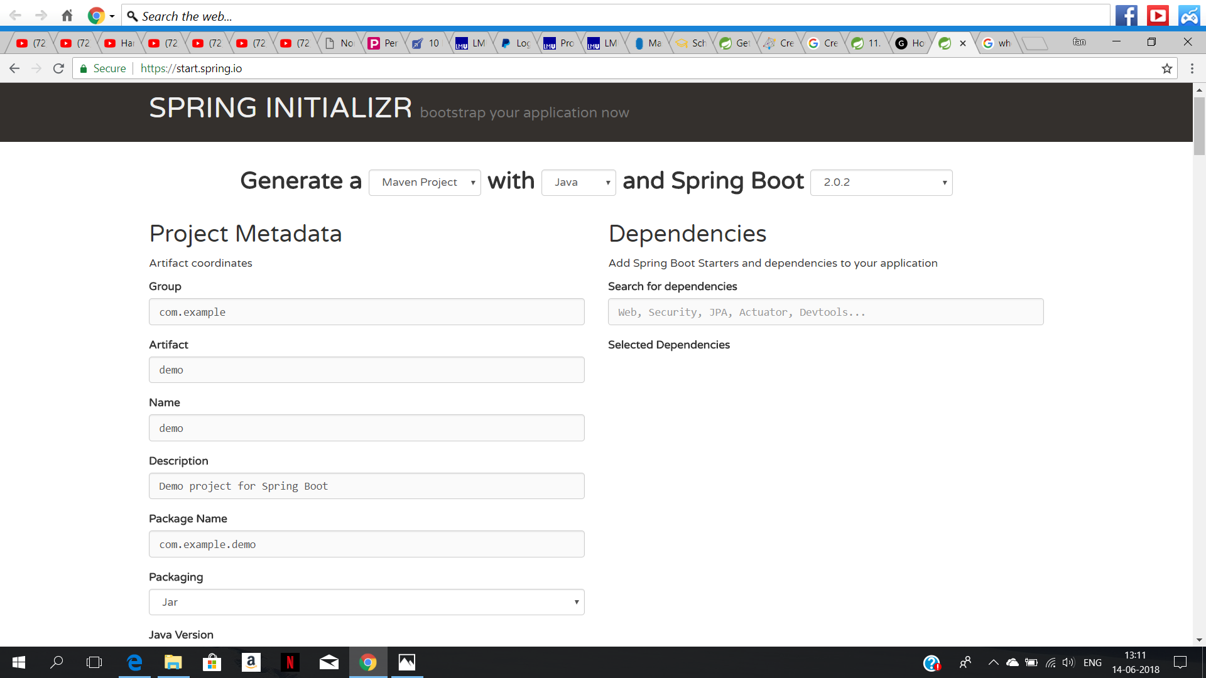

After that we will unzip the file
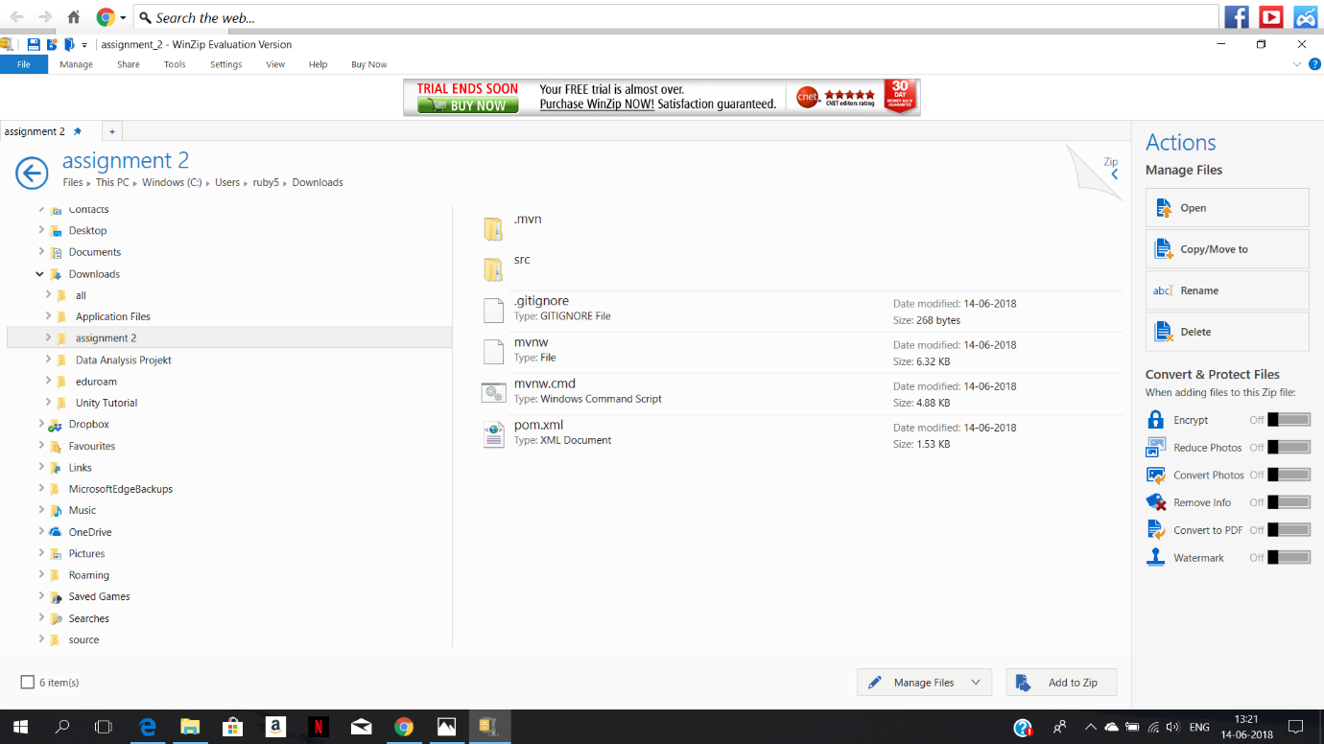

Now we can type mvn clean package and see that the build is successful
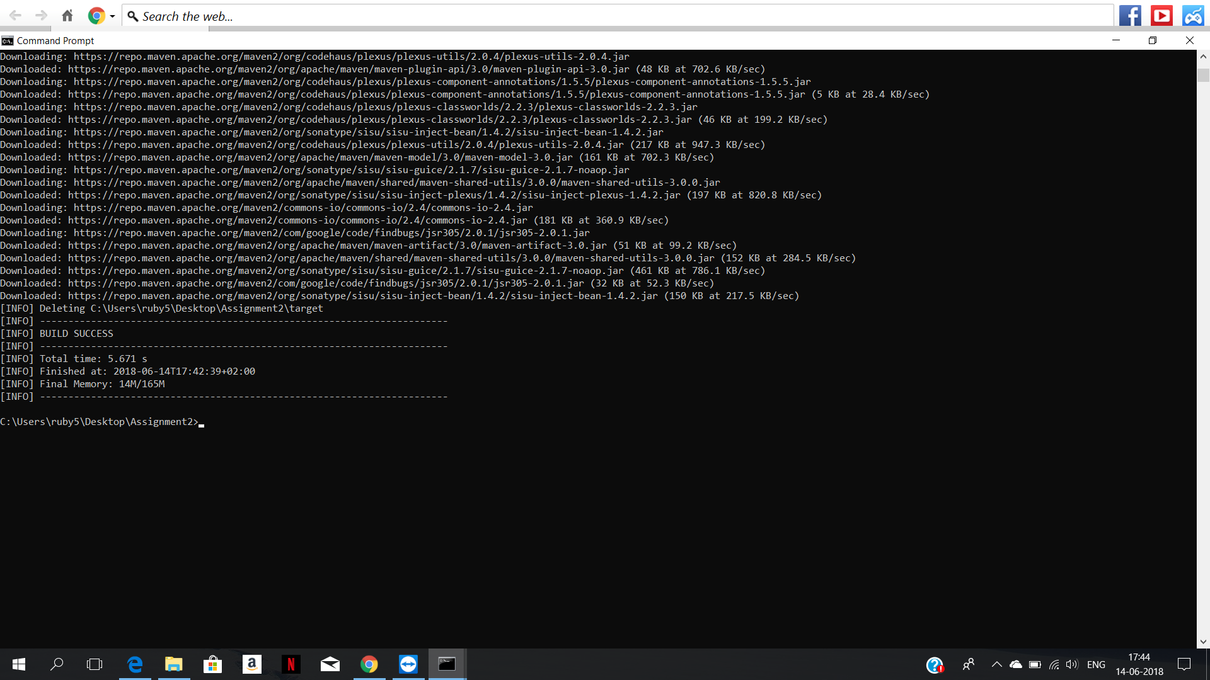
After typing java -jar target/Assignment2-0.0.1-SNAPSHOT.jar.
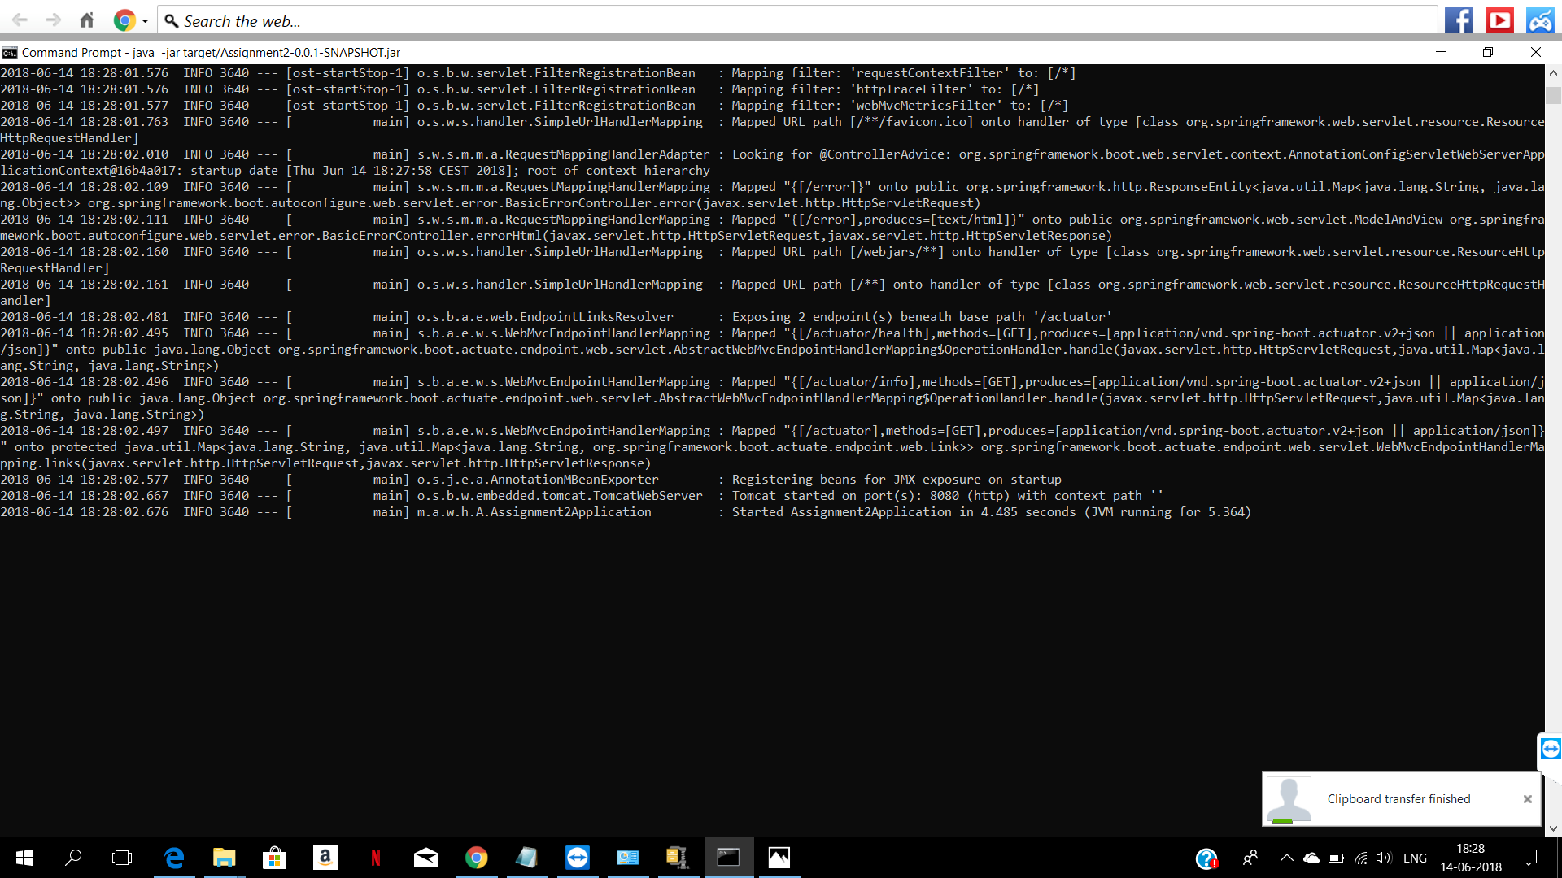

After Importing the extracted project in eclipse, we can see
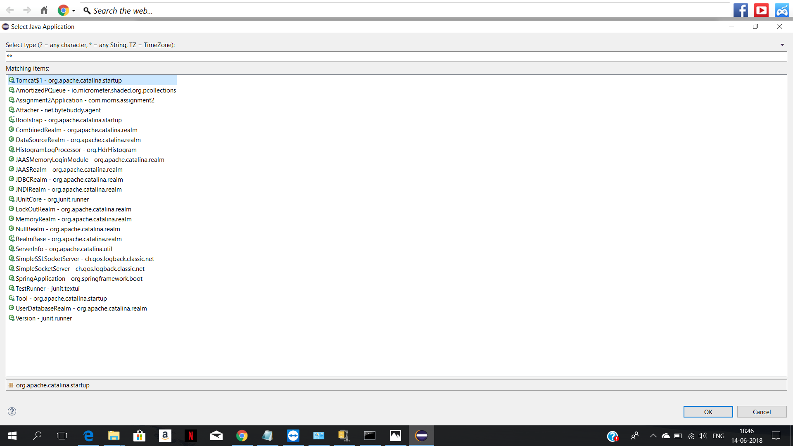

We will copy the console
